THURSDAY IS CURRY NIGHT
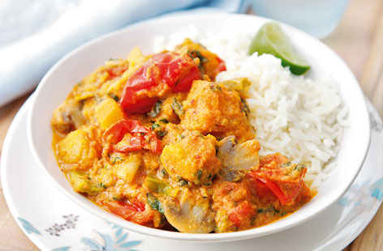
- TWO CURRIES SERVED WITH BASMATI RICE, NANN AND POPPADOM FOR ONLY £15
- SERVED FROM 5PM TILL 8.30PM
- EVERY THURSDAY

