WEDNESDAY NIGHTS IS PIE NIGHT

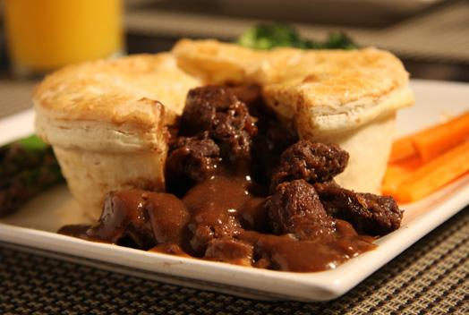
- £8.95 EACH
- SERVED FROM 5PM-8.30PM
- BOOKING ADVISABLE

