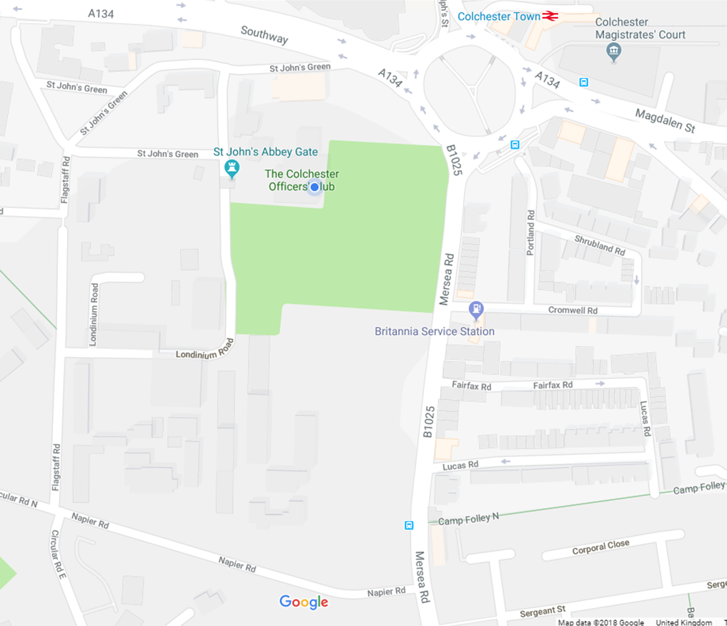

**Colchester Officers’ Club—**

**Access & Closure of the Abbey Gate**

**In the coming weeks, access to our Club will be changing. Please see below details of the new access. Once a confirmed date for closure of the Abbey Gate has been agreed, we will inform all members by email and the notice boards.**

**Arriving from Southway or Magdalen Street:**

Exit the St Botolph’s Circus roundabout (next to Colchester Town Station) onto the B1025 – Mersea Road. Take the first right onto Napier Road, then turn right onto Flagstaff Road, then the first right again onto Londinium Road. Follow the road around to the left and as you continue you will see St John’s Abbey Gate ahead of you. The Colchester Officers’ Club is located on the right-hand side before the Abbey Gate.

**Arriving from Mersea Road:**

Turn left onto Napier Road, then turn right onto Flagstaff Road, then the first right again onto Londinium Road. Follow the road around to the left and as you continue you will see St John’s Abbey Gate ahead of you. The Colchester Officers’ Club is located on the right-hand side before the Abbey Gate.